# Dharmam Buch

## Capital One Code Challenge 2

Link provided on the instruction is not opening.

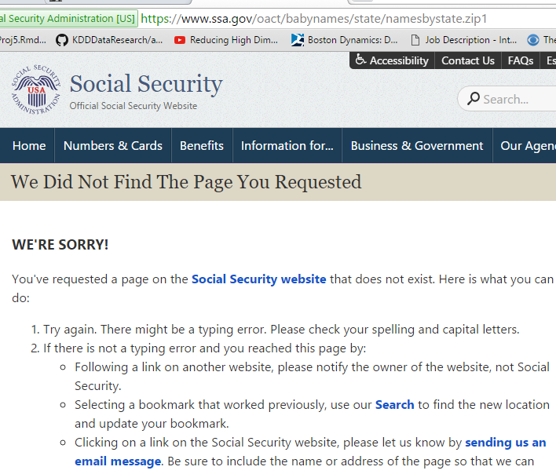

**I would like to apologies here because with my mid-terms impending, I wasn’t able to proactively search for the required data set proactively.**

**However, I was able to get few answers from taking data from the website and using the same on excel and do some basic data analysis.**

1. Please describe the format of the data files. Can you identify any limitations or distortions of the data? -**NA**

2. What is the most popular name of all time? (Of either gender.)

Male – Michael

Female – Mary

3. What is the most gender ambiguous name in 2013? 1945?

Used Data on the website.*

Jordan for Decade 2000.

Terry for Decade 1940.

4. Of the names represented in the data, find the name that has had the largest percentage increase in popularity since 1980. Largest decrease?

5. Can you identify names that may have had an even larger increase or decrease in popularity?